**Age is not a hindrance to accessing opportunities**

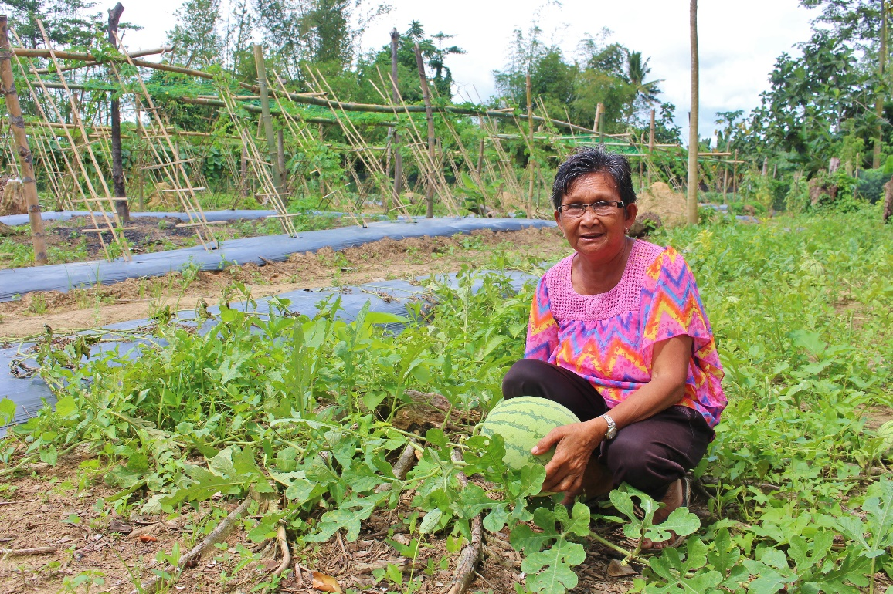

Imelda Bacor helps other farmers in her town to maintain a vegetable demo farm.

If there is one thing that Imelda Bacor is grateful for, that is the opportunity to earn from her passion.

Imelda, a 64-year-old vegetable farmer in Lemery in Iloilo, shared that farming has been part of her system. She learned it from her parents when she was ten years old.

“I live in an agriculture-dependent town and everyone knows how to farm. It has been our primary source of income to buy our daily needs,” she said.

Imelda happily shared that she has a vegetable garden in her backyard where she grows string beans, pumpkins, eggplants, taro, jackfruit, okra, etc.

“Having a backyard garden is such a big help to us especially now that I am already a senior citizen. Vegetable farming is only my source of income.”

Imelda narrated how she and her husband struggled after Typhoon Haiyan, the strongest ever that hit her town. Her house was badly damaged into pieces and her vegetable garden was not spared by Haiyan’s merciless winds.

“It was really difficult to get back on our feet because we literally lost everything. My husband and I are both old so we weren’t able to rebuild faster like our neighbors. But we didn’t give up. Our son became our source of strength so we just kept going,” she said.

Imelda married when she was 40 years old. After Haiyan, her son was still in college and about to finish his studies. She nearly let her son skip his last few semesters because of financial difficulties but she kept her hopes up.

But things have turned brighter for Imelda. Her community has become part of CARE’s Typhoon Haiyan Reconstruction Assistance project. With the support of the Government of Canada through the Global Affairs Canada, CARE provided financial assistance to farmers’ associations in Lemery to boost vegetable production. This has led to income-generating activities for small-scale farmers particularly women and the elderly.

“I am extremely happy taking part in CARE’s livelihood project in my community. I joined our farmers’ association and they even elected me as the secretary.”

In partnership with local cooperative Taytay sa Kauswagan Inc., CARE has provided skill-building training and workshops on community-based enterprise management, financial literacy, values formation, disaster preparedness, and household gender sensitization that gives a deeper understanding of shared labor in a household.

To help farmers protect their farms from natural disasters, CARE has collaborated with the Department of Agriculture and the local government unit to provide training sessions on new farming technologies and good agricultural practices.

“We’ve learned so much from all the technical assistance provided to us. Before we were not mulching in our farms. We just plant traditionally without these practices that in fact can help increase our yield, said Imelda.

“I have also learned drip irrigation, which I believe is one of the most efficient ways of irrigating because it saves us water. It is easy to set up and very applicable to our area because we sometimes experience drought during summer.”

Imelda now spends most of her morning in her vegetable garden, and once a week she goes to a demo farm that CARE has helped establish. She regularly harvests vegetables that she sells in different markets in Lemery and nearby towns.

“I am thankful that I have a stable livelihood now. Through this, I was able to support my son’s education,” said Imelda.

“I am proud of my son because he recently graduated with flying colors.”

Imelda believes that age should not hinder someone to earn and access income opportunities. After all, willpower knows no obstacles.

--

Story by Dennis Amata (Communications and Knowledge Manager.